Music proposal – Lara & Marcello’s wedding – 25 April 2021

Your wedding is an intimate reflection of you and as such requires musical and creative attention. To authentically convey that feeling to the guests sharing in this momentous day, your musical input is invaluable.
Over the next months, we’ll be working with you on your wedding soundtrack. Building on our experience of what works and what doesn’t, we’ll guide you in the repertoire selection process from guest arrivals to closing song.
Most of the suggested acts below are open to learning new repertoire, so if you’ve got something specific in mind, let us know. While we’ll try to our best to accommodate you, we’ll also be honest when we feel something won’t work musically or is not possible.
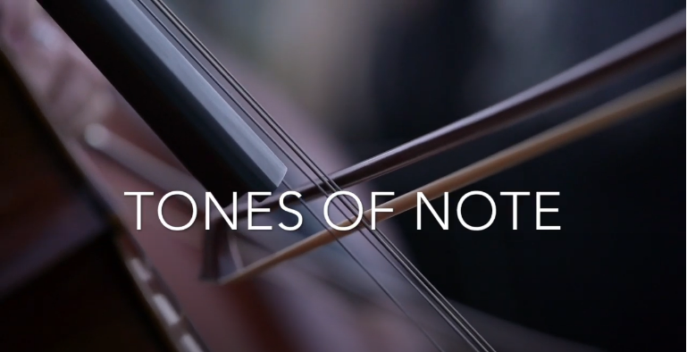

Guest arrivals: The simplest and most cost effective way of welcoming guests to your wedding is to have background music played through the PA. Depending on the type of ensemble booked for the Chuppah we could also include some live instrumental music to welcome guests to the Chuppah area.
Chuppah: Chazzan Richard Gore and keyboard accompaniment to perform selected songs for the processionals and Sheva Brachot. Here’s a video reference from the last Chuppah Richard performed - Richard Gore - Sheva Brachot
In addition to Richard and keys, we could also add a string quartet including 2 x violins, 1 x viola and 1 x cello. The addition of the strings also opens the repertoire up to include classical and contemporary songs performed instrumentally. These include options like Coldplay’s Fix You and Sky Full of Stars, Symphony by Clean Bandit and many more.

Pre-drinks: Building on the emotion created at the Chuppah, this period allows guests to catch up with friends and family while taking in their surroundings. The music during this time should animate/enliven those conversations not interfere or compete with them.

As discussed, a DJ is a good alternative to a live performer for pre-drinks, with the music during this period setting the tone for the rest of the night. Musically speaking, DJs have a broader range of styles and songs to choose from, allowing them to take the music where the guests want it to go. Ultimately this set must be upbeat, featuring songs that appeal to the majority of your guests while also representing your musical preferences.
This is achieved by playing a mix of classics from soul, jazz, reggae and current popular music. To find out which songs from those genres most resonate, we’ve included a 90-minute sampler below. Please give it a listen and send us your feedback. We’ll use that to curate the set.
Rus Nerwich - Pre-drinks Sampler
In addition to DJing, Rus will perform selected songs on saxophone. Towards the end of the set, he’ll be joined by a trumpet player performing the final 3 -4 songs before we’re ready to move to the Horas area. Rus and the trumpet player will then go mobile, leading the guests to the Horas stage.

Horas: As soon as the band hears Rus and the trumpet player approaching, the rhythm section will kick in building anticipation for your arrival. Nathan Ambach will sing and direct the Horas, interacting with the guests as he does, making sure to get everyone involved.
The size of the Horas ensemble depends on where the stage is positioned and whether we go with the option of having a big band. I’ve broken down these options below:
Option one: Outside courtyard area
If we decide on the Horas taking place outside the entrance to the courtyard area, we’d go with a 6-piece ensemble including Nate on vocals, accompanied by keys, bass and drums and Rus and the trumpet player.
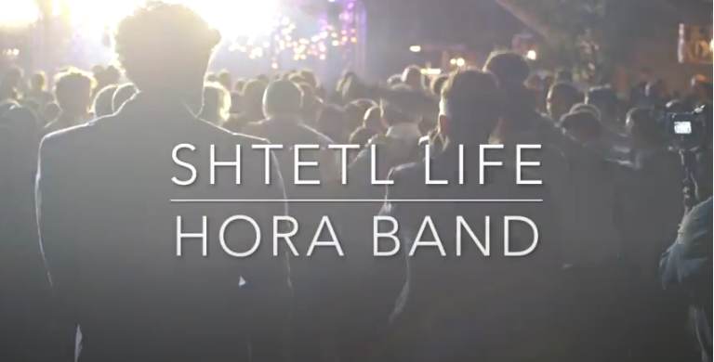
Option two: Inside reception area.
Alternatively, if we go with the option of having a big band, it makes more sense to use the reception area as the location for the Horas. This would mean that the dinner and dance area are revealed earlier in the timeline and that guests need to make the transition from pre-drinks to inside the reception area in one go.
The Horas ensemble for option two would comprise of Nate on vocals, accompanied by 6-piece horn section including 3 x saxophones, 2 x trumpets and 1 x trombone, as well as keys, bass and drums to perform 15-20 minute set similar to the style and feel seen in this video above.

Dinner: Like the Horas set, the entertainment for dinner, depends on whether you go for the big band option or not.

Option one: If you decide to stick to a smaller ensemble for the Horas and Dance set, then it would be better to have Rus DJ during the dinner set. Not only will this allow us to incorporate the big band repertoire you like, but it’ll also be easier from a logistical standpoint as a DJ requires a simpler setup.
Option two: If you decide to go for the big band option, the repertoire here will include a mixture of instrumental songs as well as songs that feature vocals, on which Nathan will take the lead. The dinner set repertoire will build in tempo leading up to the benching, which we can perform on the dancefloor, bringing people together ahead of your first dance. Directly following your first dance, which we’ll move to the big band’s dance set that will traditional dance arrangements such as Sing Sing Sing and more contemporary ones like 24k Magic.

Dance: If we go with option one for dinner, after benching has been concluded and guests are ready, the doors to the final dance party area will be opened, revealing an 8-piece band including Nathan Ambach and Francesca Biancoli on vocals, accompanied by keys, guitar, bass, trumpet, saxophone and drums. Touring and performing together for the last 6 years, Rus Nerwich and Nathan Ambach (N8N) have developed an electric onstage chemistry, offering clients an all-inclusive musical solution.
Both Nathan and Rus bring together 20 years of musical and performance experience. From world-class live performances of quintessential classics covering soul, funk, blues, pop and jazz to a dance till you can’t dance no more DJ set, you are guaranteed one of the greatest parties of your life!

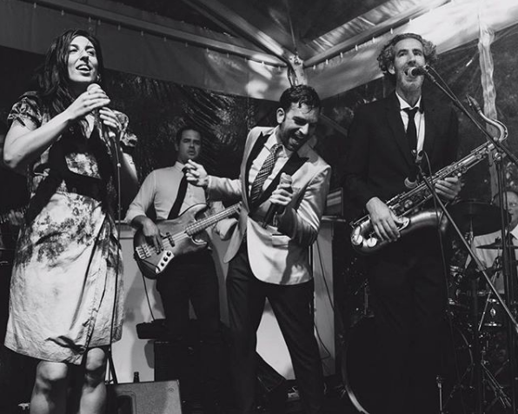

For more videos of the band’s past performances, please see the following links:

Instagram - Starlight Band - Prince - Kiss
Instagram - Starlight Band - Prince - Kiss (2)

Party: Straight from the band’s last song, we transition into the party set which will feature Nathan as the DJ. Nathan launched the nightlife series: The Love Below as ‘Your Monthly Rendezvous with Soul’ in 2006 in his hometown of Antwerp, where he is still the resident DJ + promoter of funky music worldwide!
He’s DJ’d alongside Mark Ronson at the WMC in Miami and played at the Love Below with DJ Jazzy Jeff (The Fresh Prince), DJ Premier, DJ Maseo (De La Soul), and DJ Rashida – the official tour DJ of Prince and Bruno Mars and DJ'd sets in clubs and events around Europe, America, Asia, Africa and the Middle East.
His Spotify playlists and online mixtapes represent his funky style, championing soulful music with great grooves and party hooks. For over 20 years, N8N has been rocking the business from BBQs to Bar-Mitzvahs!
N8N - The DJ Side of the Story
N8N - Mixcloud

